# Laboratory 9

Title of the Laboratory Exercise: Interfacing to Arduino UNO

1. Introduction and Purpose of Experiment

Students will be able to perform basic programming on Arduino UNO board

1. Aim and Objectives

Aim

To understand Arduino programming language and to develop basic programs using Arduino programming language.

Objectives

At the end of this lab, the student will be able to

* + Explain analog and digital pins in Arduino
  + Basic hardware programming language
  + Interface sensors and read values from sensors
  + Drive actuators

1. Experimental Procedure

1. Write algorithm to solve the given problem

2. Translate the algorithm to Arduino programming language

3. Execute it in Arduino IDE

4. Create a laboratory report documenting the work

1. Questions

Perform the following:

1. Interfacing Sensor and based on the sensor value perform the required operation
2. Calculations/Computations/Algorithms

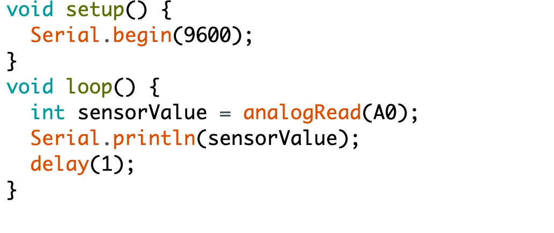

1. Presentation of Results

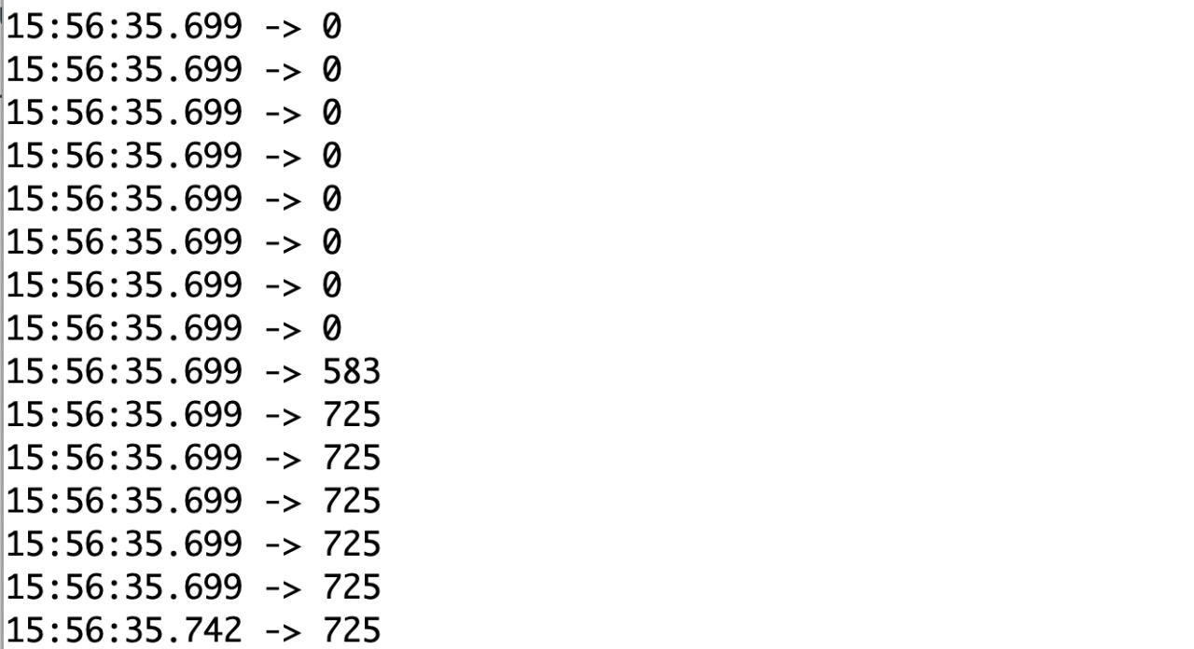

1. Analysis and Discussions
2. Conclusions
3. Comments
   * + 1. Learning happened

In this lab we have learnt how to explain analog and digital pins in Arduino, hardware

programming, interfacing sensors and read values from sensors.

Signature and date Marks